Bennett Lawrenz

Kevin Nguyen

HW6 asm_ arrays

Solution for problem 1

i/o 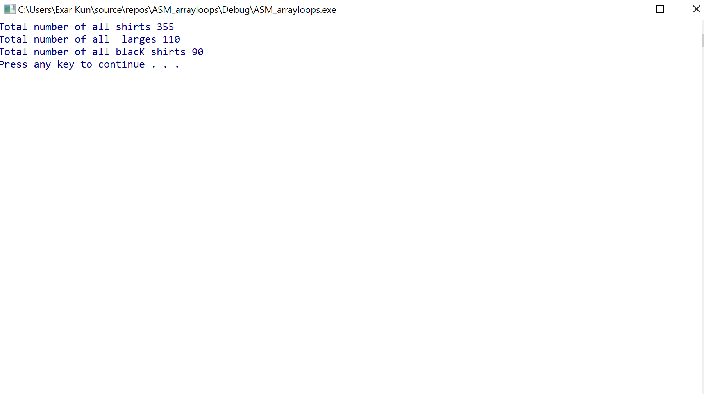

Code attached at the back

Soultion for number 2

i/o

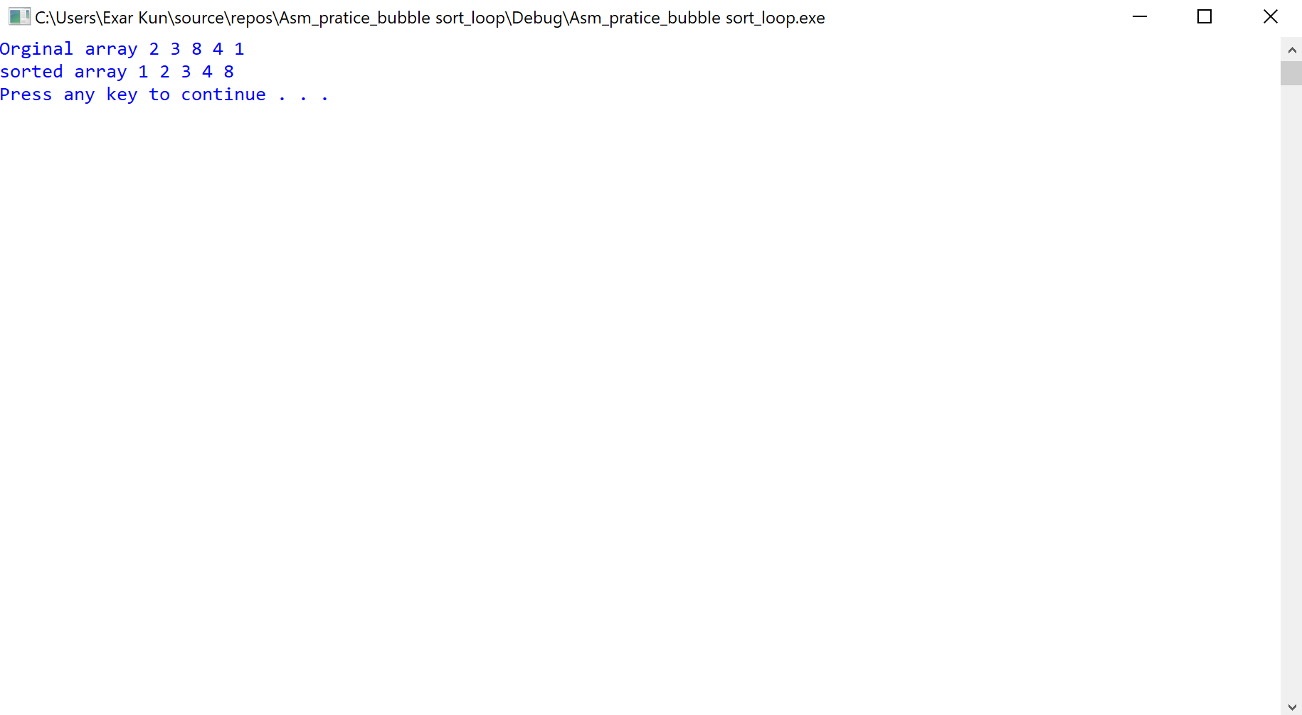

Code attached to the back

Solution for problem 3

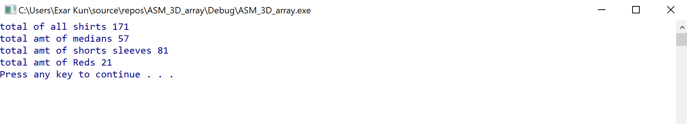

Code attached to be back